Multiple choice section – choose the correct answer

Question 1 [6.1]

For the triangle shown, the adjacent side is:

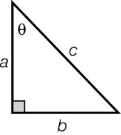

A *a* B *b* C *c*  D θ

Question 2 [6.1]

For the triangle shown, the hypotenuse is:

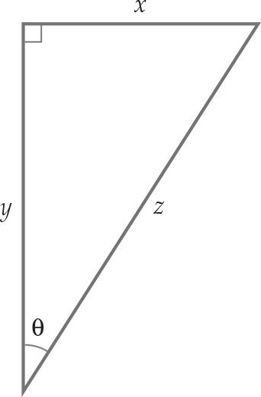

A θ B x C y D z

Question 3 [6.1]

For the triangle shown, the calculation that you would choose is:

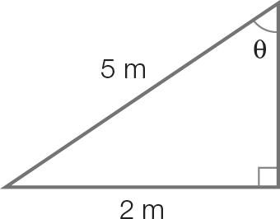

A sin (θ) = B cos (θ) = C tan (θ) = D a2 + b2 = c2

Question 4 [6.1]

For the triangle shown, the trigonometric function that you would choose is:

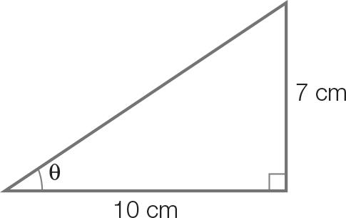

A a2 + b2 = c2 B sin (θ) = C cos (θ) = D tan (θ) =

Question 5 [6.2]

The value of *x* is:

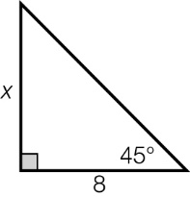

A 8 B 12 C 4 D 16

Question 6 [6.2]

The value of *y* is:

PM10_PR_FT_5_03

A 9.4 m B 9.96 m C 10.06 m D 1.4 m

Question 7 [6.3]

The value of θis closest to:

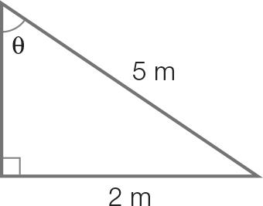

A 2.5 B 10 C 24 D 66

Question 8 [6.5]

The following angle as a true bearing is:

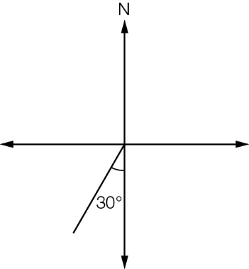

A 030°T B S30°W C W60°S D 210°T

Multiple-choice total marks: \_\_\_\_ / 8

Short answer section

Question 9 4 marks [6.6]

(a) Using Pythagoras’ theorem, b2 = c2 – a2, find the value of b.

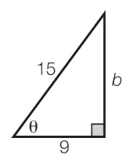

(b) Find the value of θ. Write your answer correct to the nearest degree.

Question 10 4 marks [6.2, 6.3]

(a) Find the value of y to the nearest whole number.

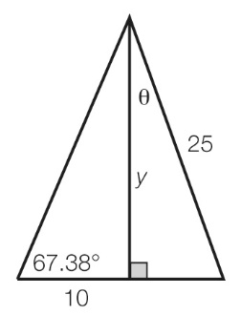

(b) Find the value of θ. Write your answer correct to the nearest degree.

Question 11 2 marks [6.4]

Having some trouble with her smartphone reception, Ange holds her smartphone up. The angle of elevation between her eye and the smartphone is 63, and the height is as shown in the diagram below. Calculate the distance that the phone is now away from her eye. Write your answer to the nearest centimetre.

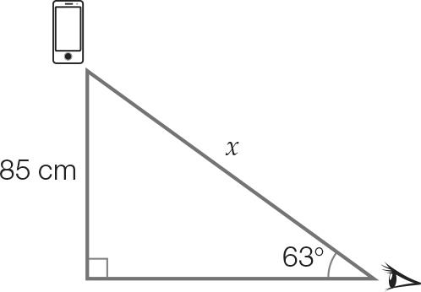

Question 12 2 marks [6.4]

A lifesaver is sitting in a 12 m tall tower and sees a swimmer in distress. The angle of depression to the swimmer is 23. Calculate the horizontal distance, correct to 1 decimal place, the lifesaver must travel to reach the swimmer.

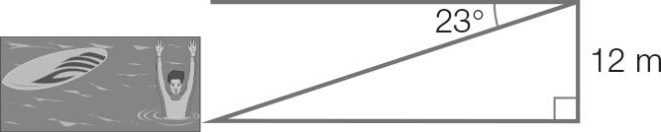

Question 13 2 marks [6.5]

For the angle shown on the right, write the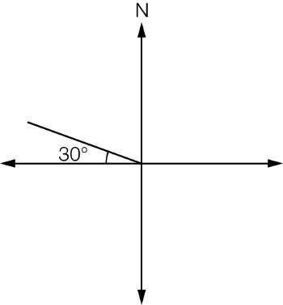:

(a) compass bearing

(b) true bearing.

Question 14 4 marks [6.5]

A bushwalker walks due south for 15 km. As shown on the diagram she then walks due east. She finds a path that will get her back to the starting point, it is on a bearing of S42E.

(a) How far east has she walked? Write your answer correct to one decimal place.

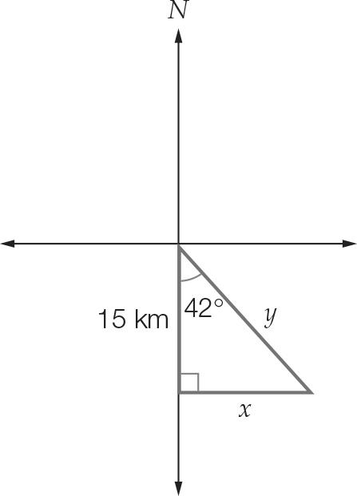

(b) How far does she need to walk if she walks back ‘as the crow flys’? Write your answer correct to 1 decimal place.

Question 15 7 marks [6.6]

A ladder 4 m in length leaning overhangs a wall and makes an angle of 29° with the ground. The end of the ladder touches the top of the tree.

(a) What is the height of the wall, to the nearest cm?

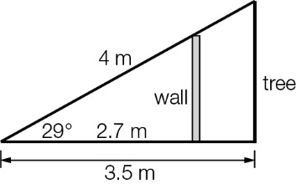

(b) How many centimetres of the ladder overhangs the wall?

(c) How much taller than the wall is the tree?

Short answer total marks: \_\_\_\_ / 25

Extended response section

Question 16 5 marks [6.6]

Camilla dives off board 1, which is 2.4 m above the pool and her hands make contact with the water 6.3 m from the base of the board.

(a) Assuming Camilla’s diving trajectory was a straight line, at what angle, θ, to the horizontal did she hit the water? Answer correct to the nearest degree.

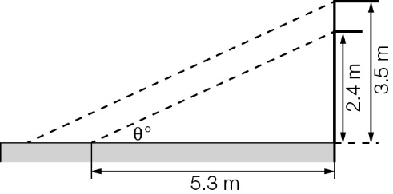

(b) Camilla climbs up to board 2 and dives, entering the water at the same angle as before. How much farther did she hit the water than her first dive?  
Answer correct to 2 decimal places.

Question 17 6 marks [6.6]

A crane lifts a container 1.2 m above the ground. The container is 2 m high and the cable is attached at the top of the cable.

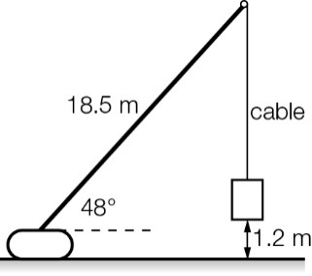

(a) What is the length of the vertical cable? Answer correct to 2 decimal places.

(b) The crane is moved 4 m closer to the container. At what angle should the crane operate so that the container remains in the same position and the same height as previously?

Extended answer total marks: \_\_\_\_ / 11

TOTAL test marks: \_\_\_\_ / 44